**Report Lab02**

**Student’s name: Chu Văn An**

**Student's ID: 20235582**

1. Use case diagram
2. Class diagram

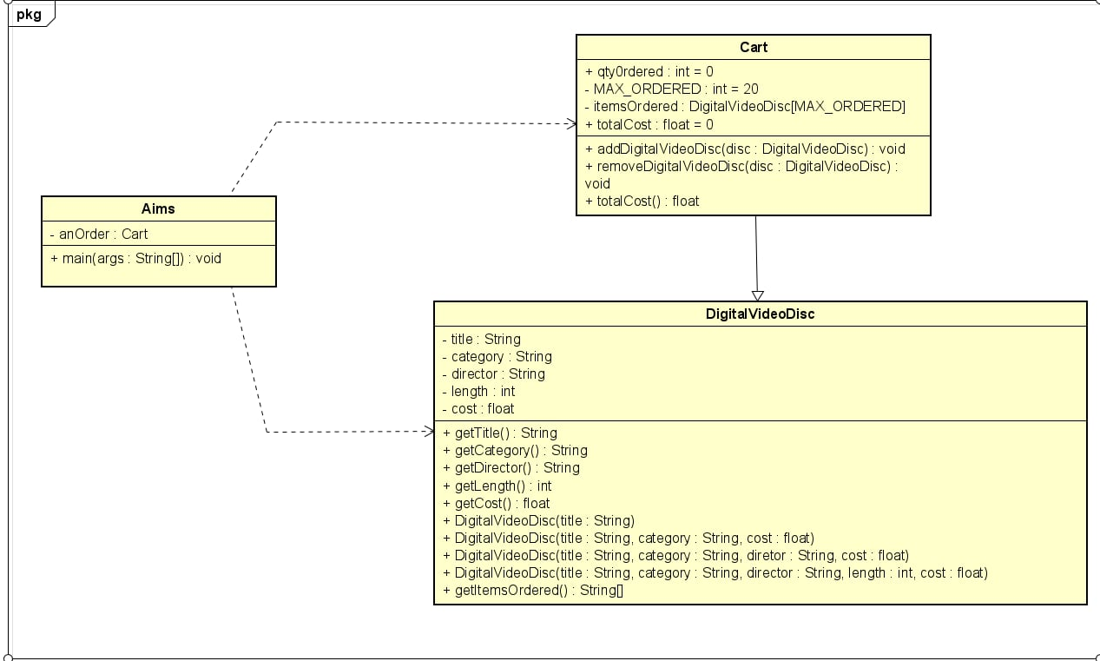

1. Reading assignment

1. Answering question

**Question:**

- If you create a constructor method to build a DVD by title then create a constructor method to build a DVD by category. Does JAVA allow you to do this?

**Answer:**

- These two constructors take the same number and type of parameters, hence it will result in a error, because in order to differentiate between constructors, they must have different signatures.